Argo CD
- Setup ARGO CD
Step 1: Check your cluster
Run this on the machine where kubectl is configured:
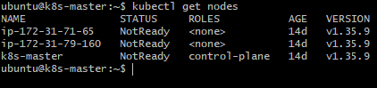
Kubernetes nodes should be in Ready status.
Step 2: Create the Argo CD namespace
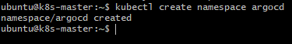
Step 3: Install Argo CD
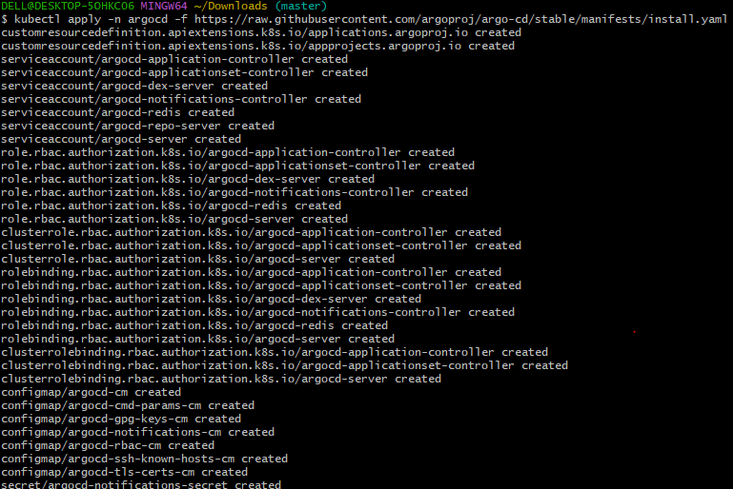
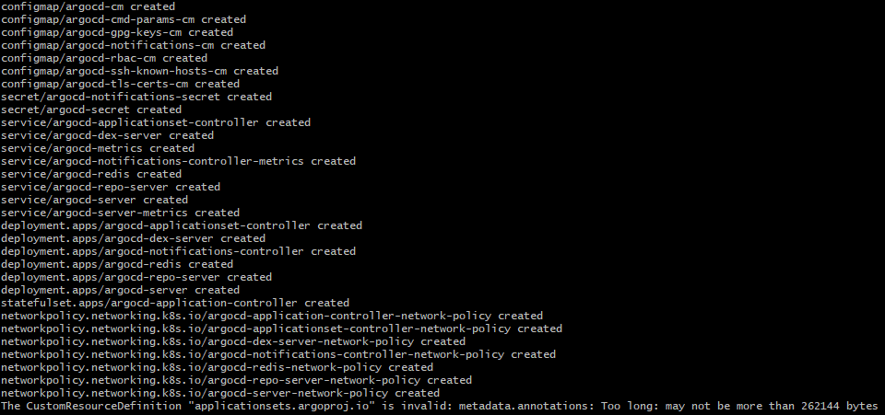

This installs Argo CD components into the argocd namespace.

Step 4: Check Argo CD pods
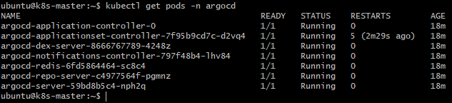

Wait until the pods are Running or Completed.
Step 5: Check the Argo CD service
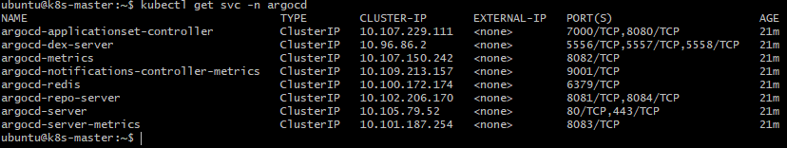

By default, Argo CD's server is a ClusterIP, so it isn't directly accessible from your PC.

Step 6: Then open in your Windows browser:

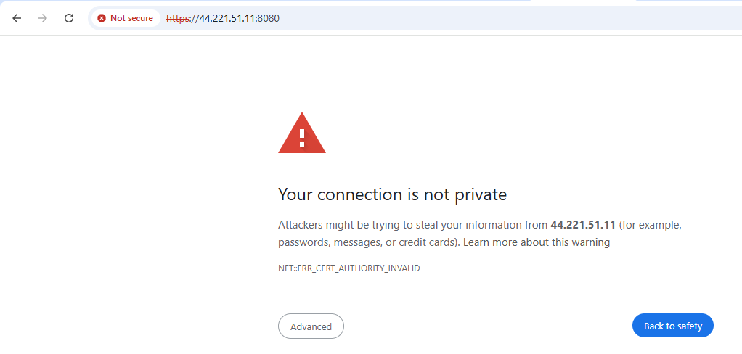
There is a certificate warning. So choose Advanced → Proceed.

Step 7: Get the initial admin password

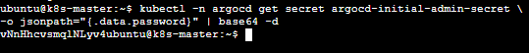
Copy this password. vNnHhcvsmqlNLyv4
Now Use:
Username: admin
Password: vNnHhcvsmqlNLyv4
You should now see the Argo CD dashboard.
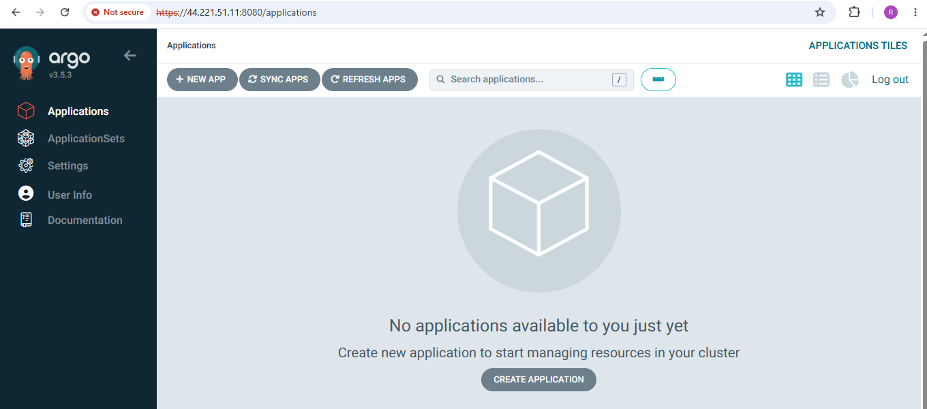
2. Create Jenkins job for CI.
Step 1 — Open Jenkins and create a new Jenkins job
Open your Jenkins URL in your browser: http://<JENKINS-IP>:8080
Log in as admin.
Click: New Item
Enter a job name, for example: CI-Pipeline
Select: Freestyle project
Click: OK
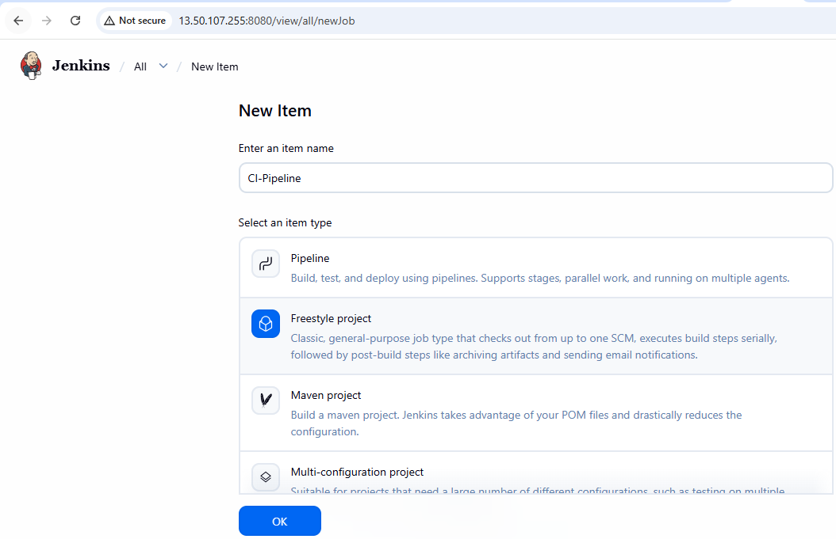

Step 2 — Configure Git
Under Source Code Management:
Select: Git
Enter your Git repository URL: https://github.com/betawins/hiring-app.git
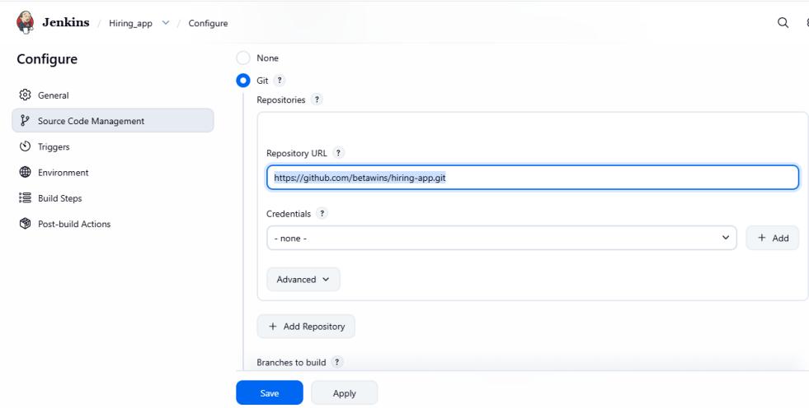

Step 3 — Add the build step
Scroll to Build Steps.
Click:
Add build step → Execute shell

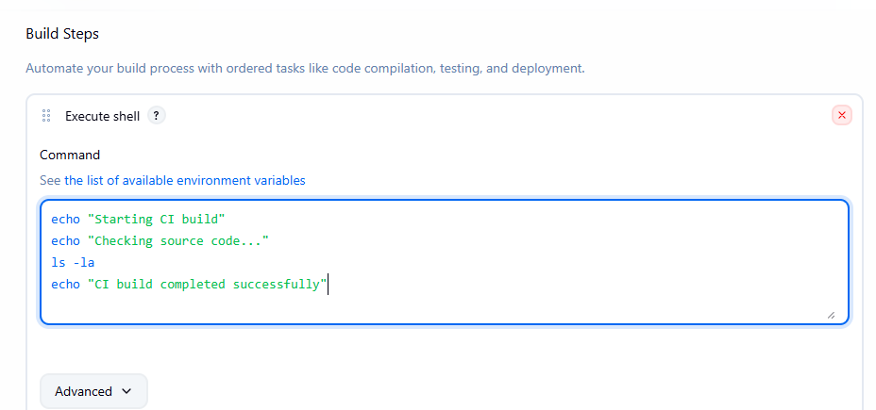
Click save.

Step 5 — Run the CI job
On the job page, click: Build Now
Jenkins will create: Build #1
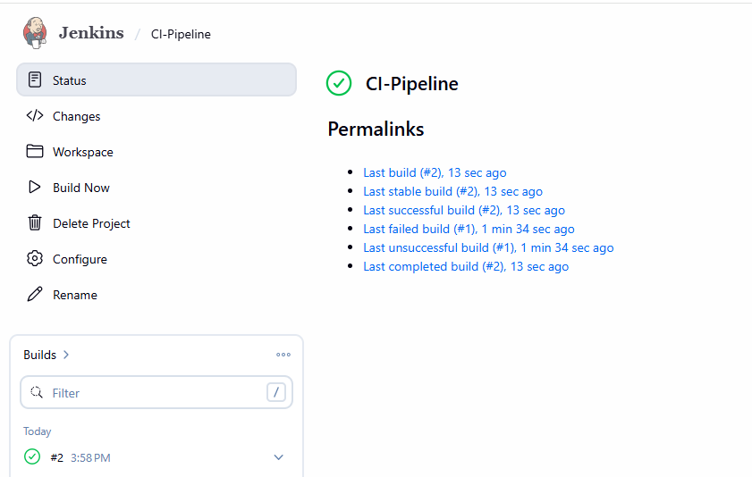
Click the build number → Console Output.
You should see the Git checkout followed by your build commands.
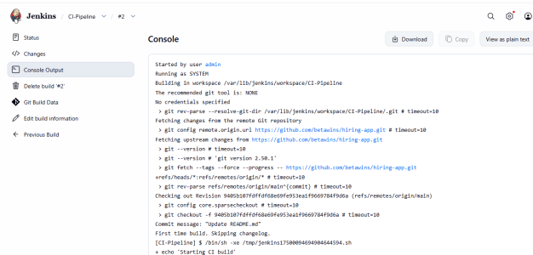
3. Create Jenkins job to create docker image and build image.

Step 1 — Create the job
In Jenkins: Dashboard → New Item
Job name: Docker-Build
Select: pipeine
Click OK.
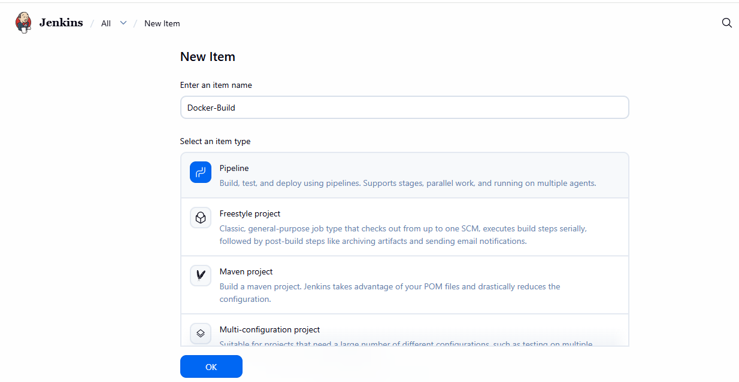

Step 2 — Configure Git
- Scroll down to the Pipeline section.
- Set Definition to Pipeline script

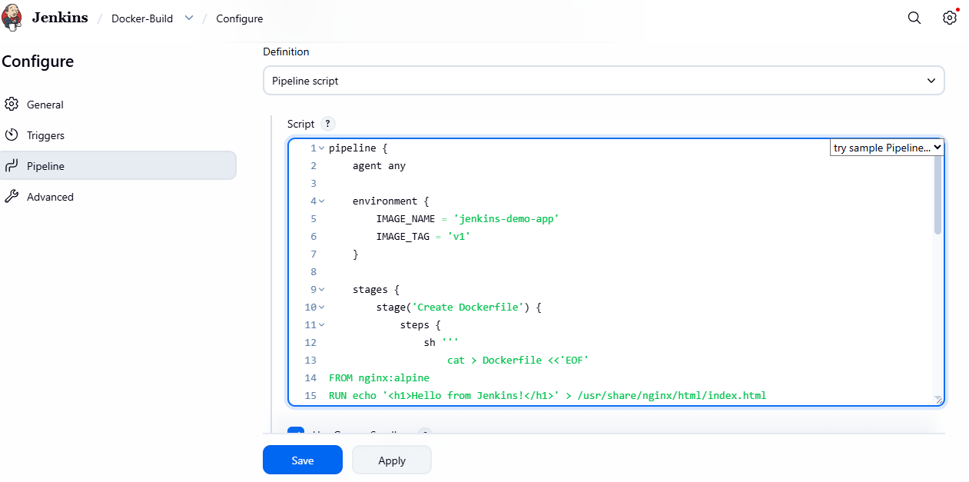
This pipeline creates a simple Nginx-based Docker image named jenkins-demo-app:v1.

Step 3: Run the job
- Click Save.
- Click Build Now.
- Open the latest build number.
- Click Console Output.
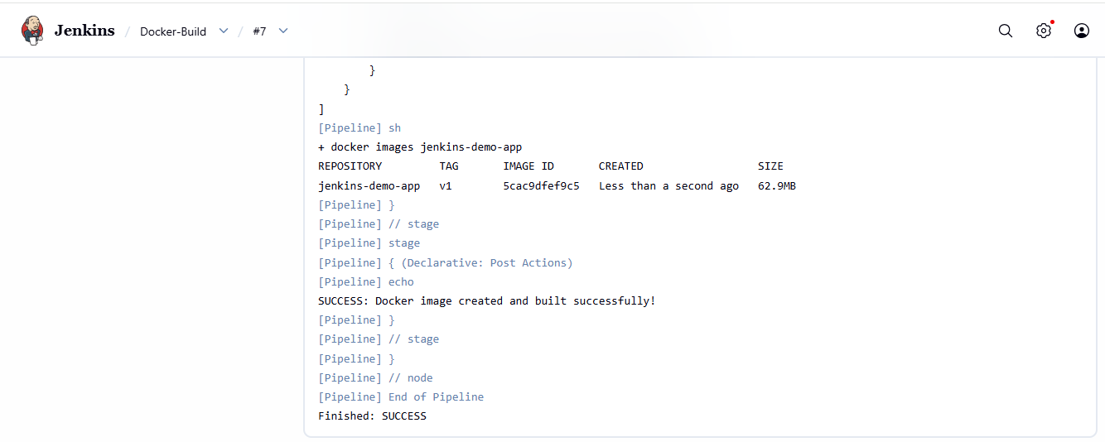
Stage view:
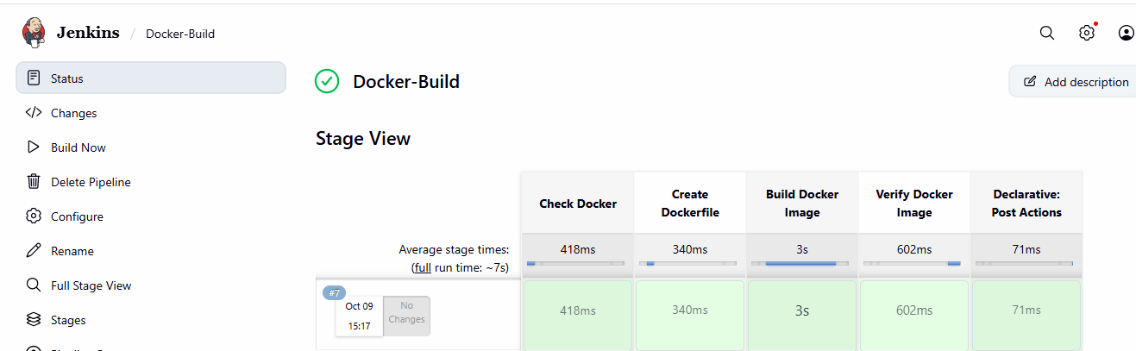
Verify the image on Jenkins-server:
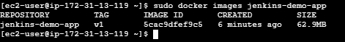
Run your Docker image jenkins-demo-app:v1 as a container in the background.

4. Create ArgoCD job to deploy on ek8s cluster.
Step 1: Update the cluster:
Cluster name is my-eks-cluster, and your region is us-east-1.

Step 2: Install Argo CD on EKS
Create the Argo CD namespace:
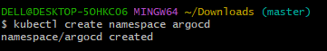
Verify:
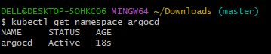
Install Argo CD:
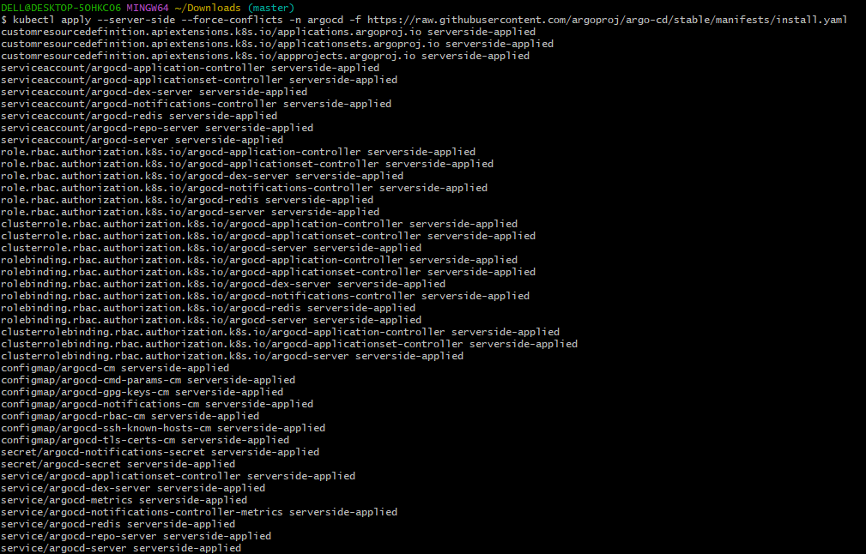
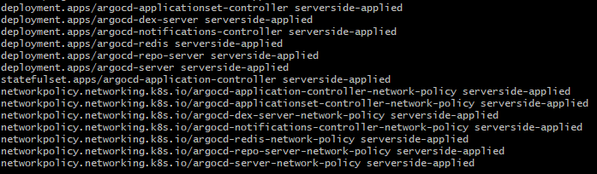

Step 3: Download AgroCD repo in k8s Master
git clone: https://github.com/rojalatha49-bit/java-argocd.git
ls
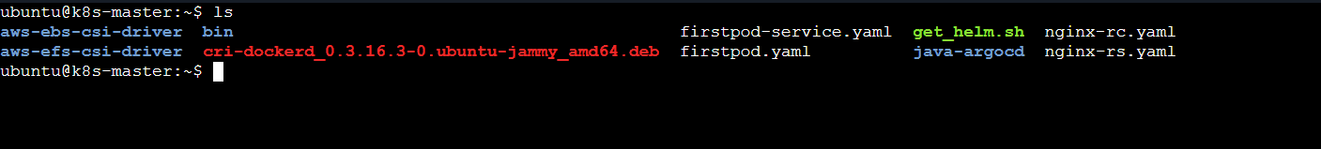
Move into repo file:
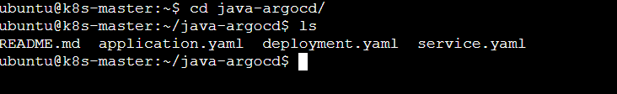

Step 3: Show the file in Agrocd
Cat application.yaml
deployment.yaml
serveice.yaml
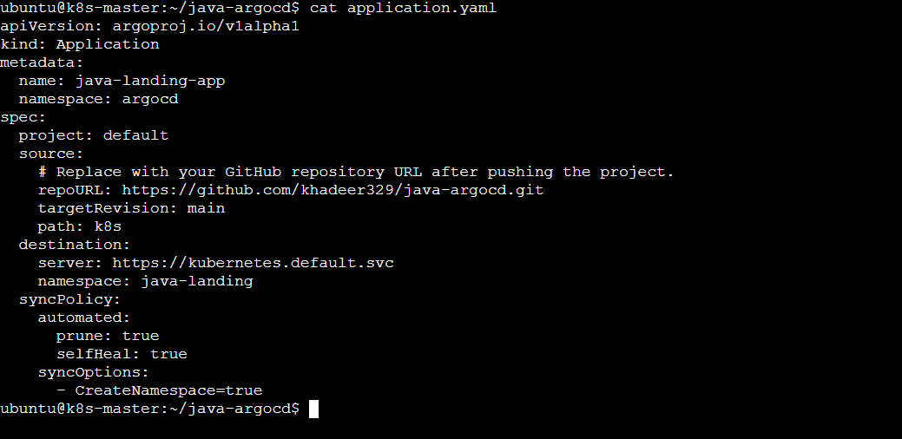
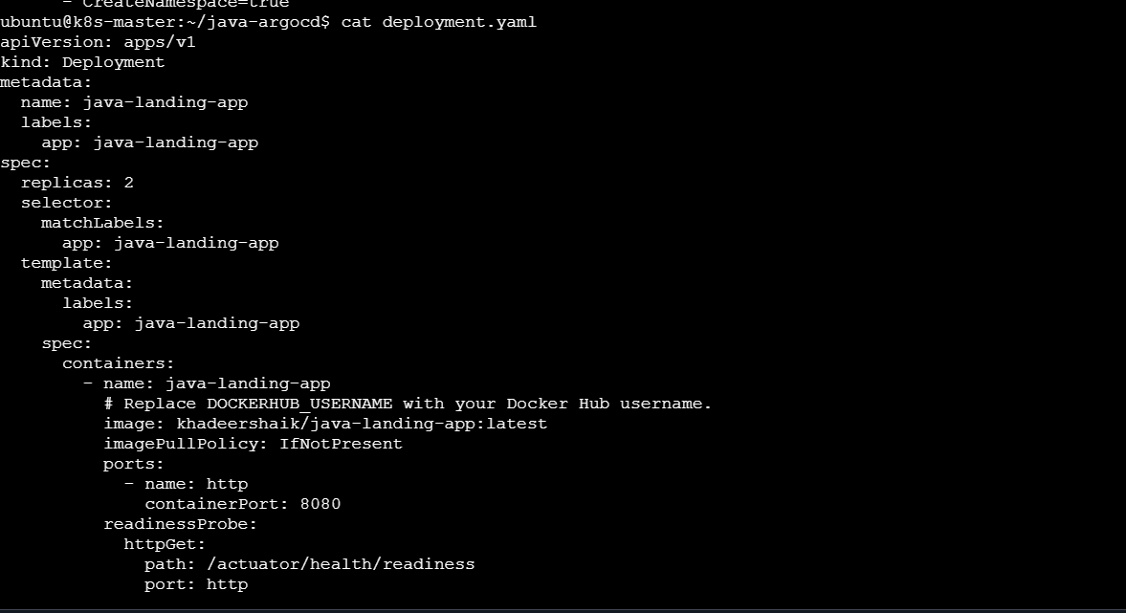
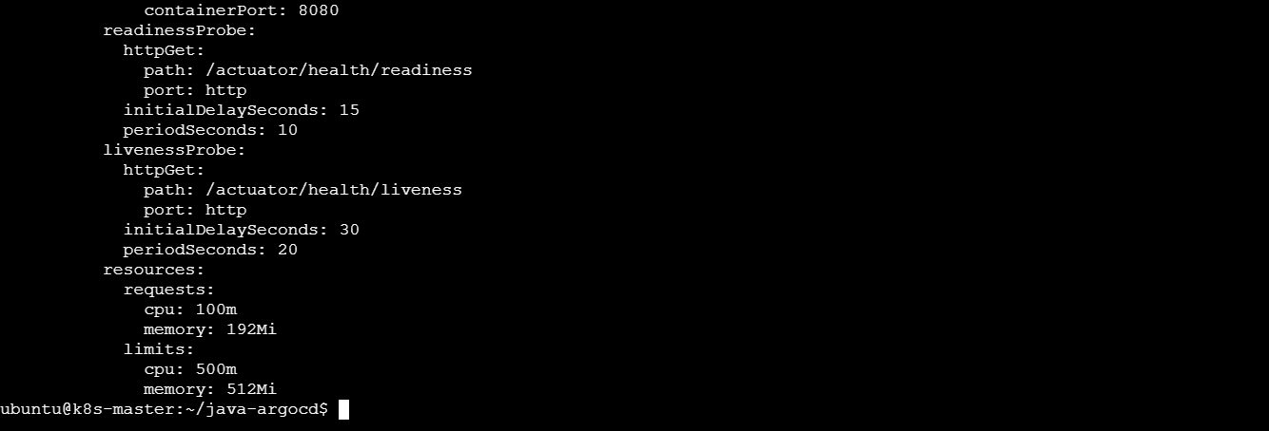

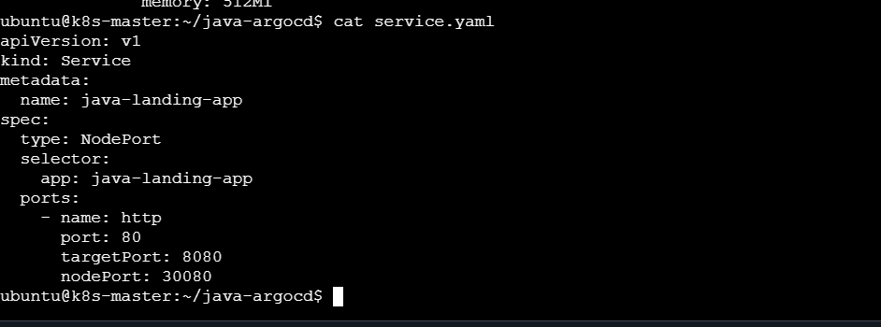

Step 4: Apply application yaml and Confirm the Application Syncs
kubectl apply -f application.yaml
kubectl get application java-landing-app -n argocd
kubectl get nodes -o wide
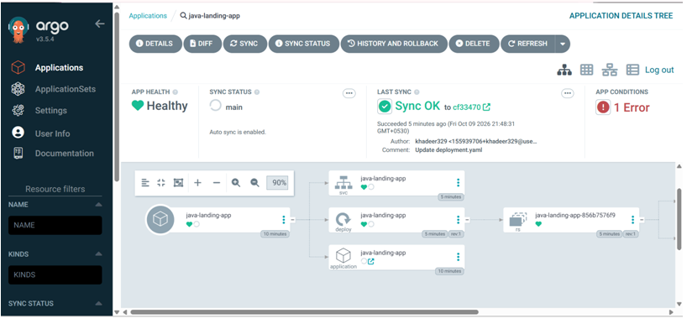
kubectl get svc java-landing-app -n java-landing
